Practical - 11
Practical Title: Student Management CRUD with Search and Filter

Create a student management module to add, view, edit, delete, search and filter student records. All database operations must use MYSQLi statements and clear success/failure messages.

Theory
1. Are SELECT, INSERT, UPDATE, and DELETE operations working?
- SELECT: Working – Retrieves and displays records from the database.
- INSERT: Working – Adds new records to the database.
- UPDATE: Working – Modifies existing records in the database.
- DELETE: Working – Removes records from the database.
2. Is search by name/email/course implemented?
- Yes, search by name, email, and course is implemented.
- Users can search for specific records using the search functionality.
- The system displays matching results based on the entered keyword.
3. Are delete operations confirmed before execution?
- The system accepts a keyword entered by the user.
- It searches for matching records in the database.
- It displays results relevant to the entered keyword.
- If no match is found, it displays an appropriate message.
Implementation/Output/Result

My learning codes: https://drive.google.com/file/d/1CPP3uUq3gdKZxC3pFB7iheZVU7FCImSx/view?usp=drive_link

Evidence of Work (Screenshots)

Structure and Browse View of the Students Table:
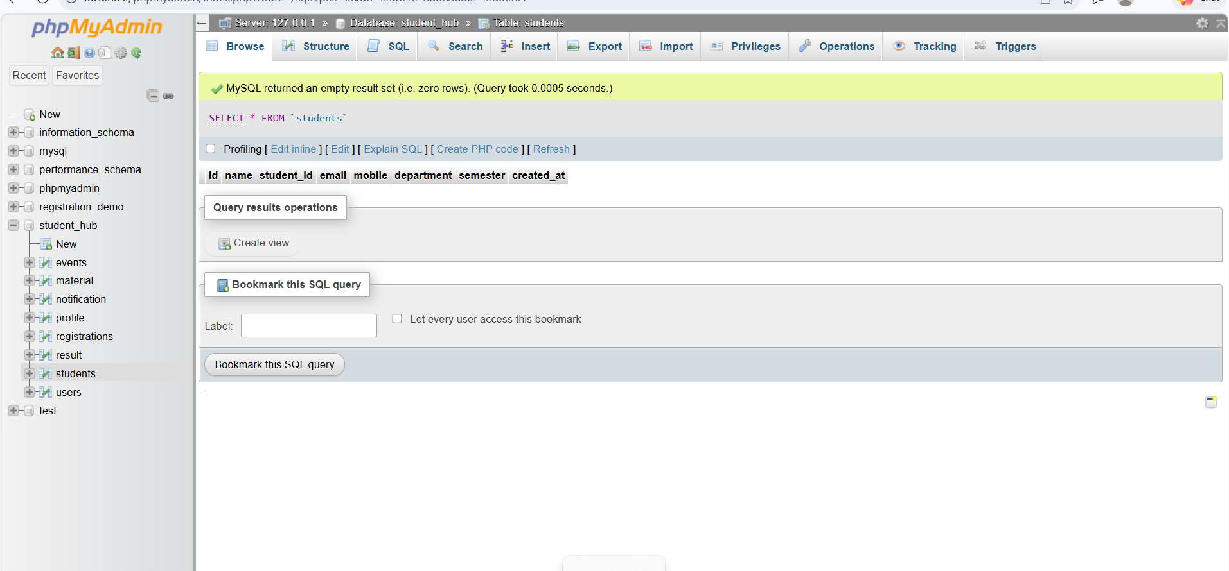
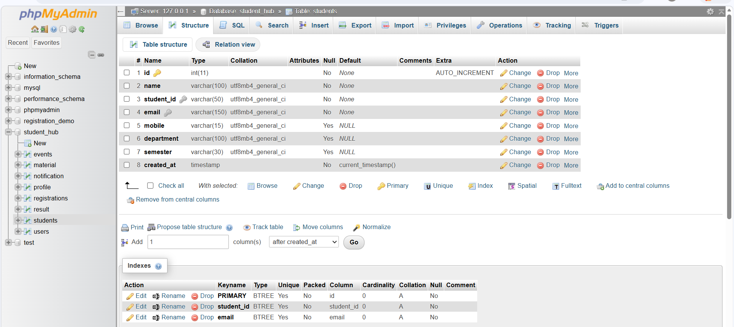
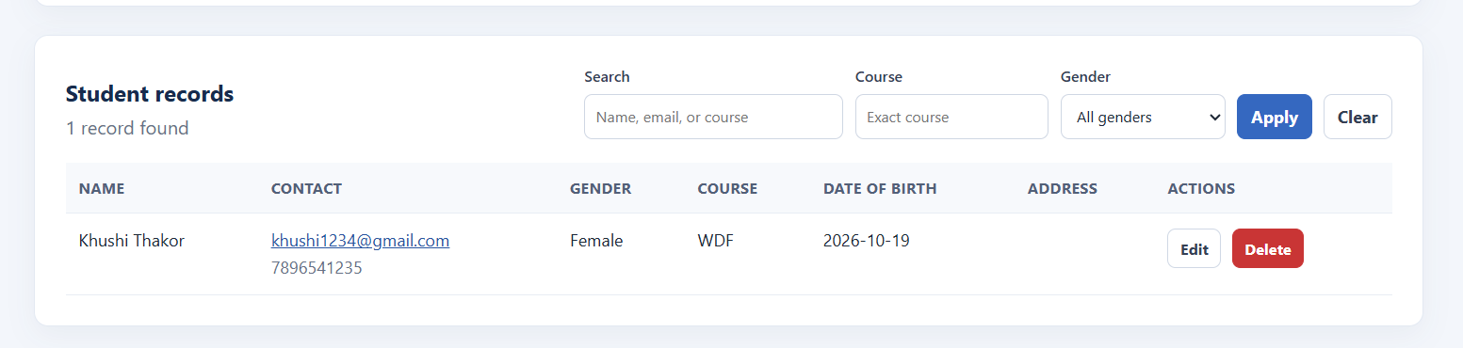
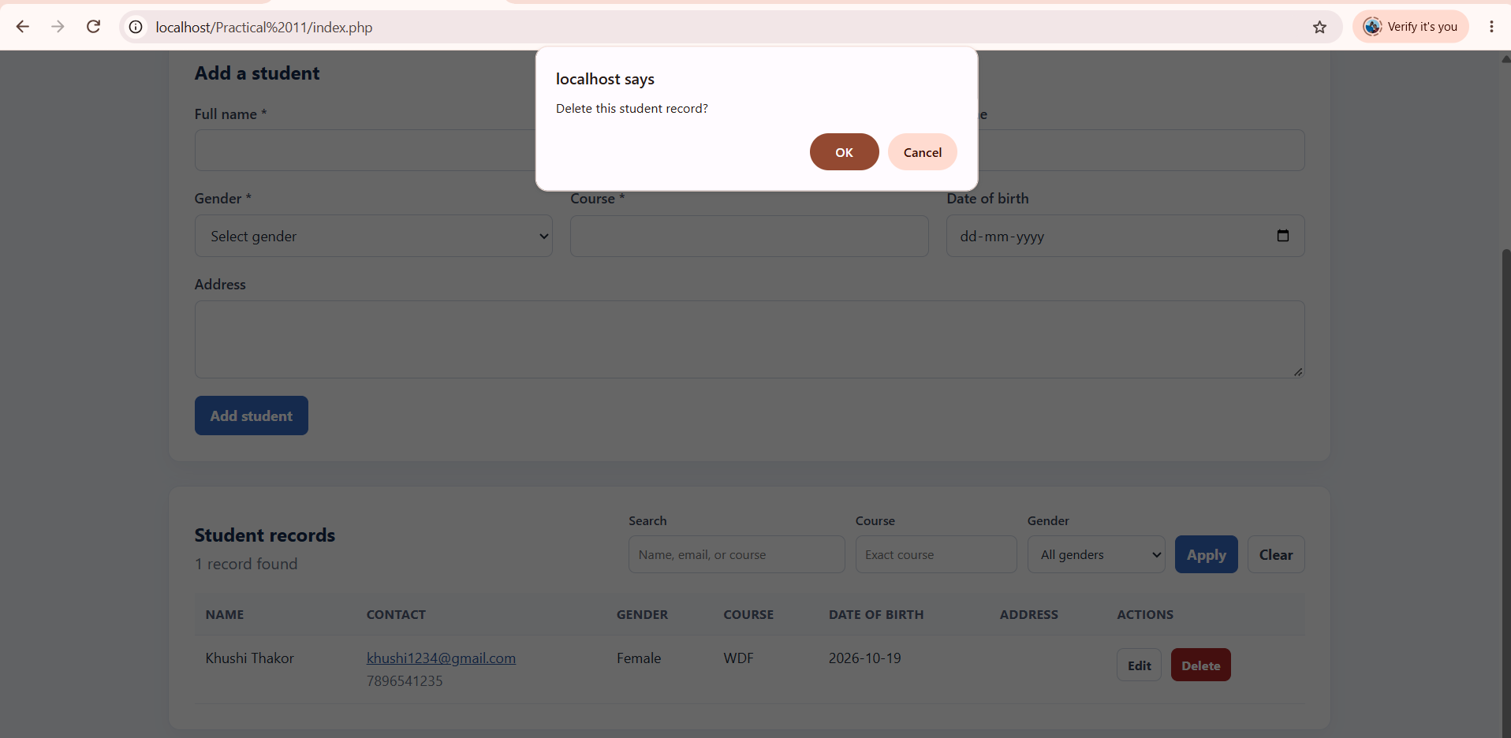
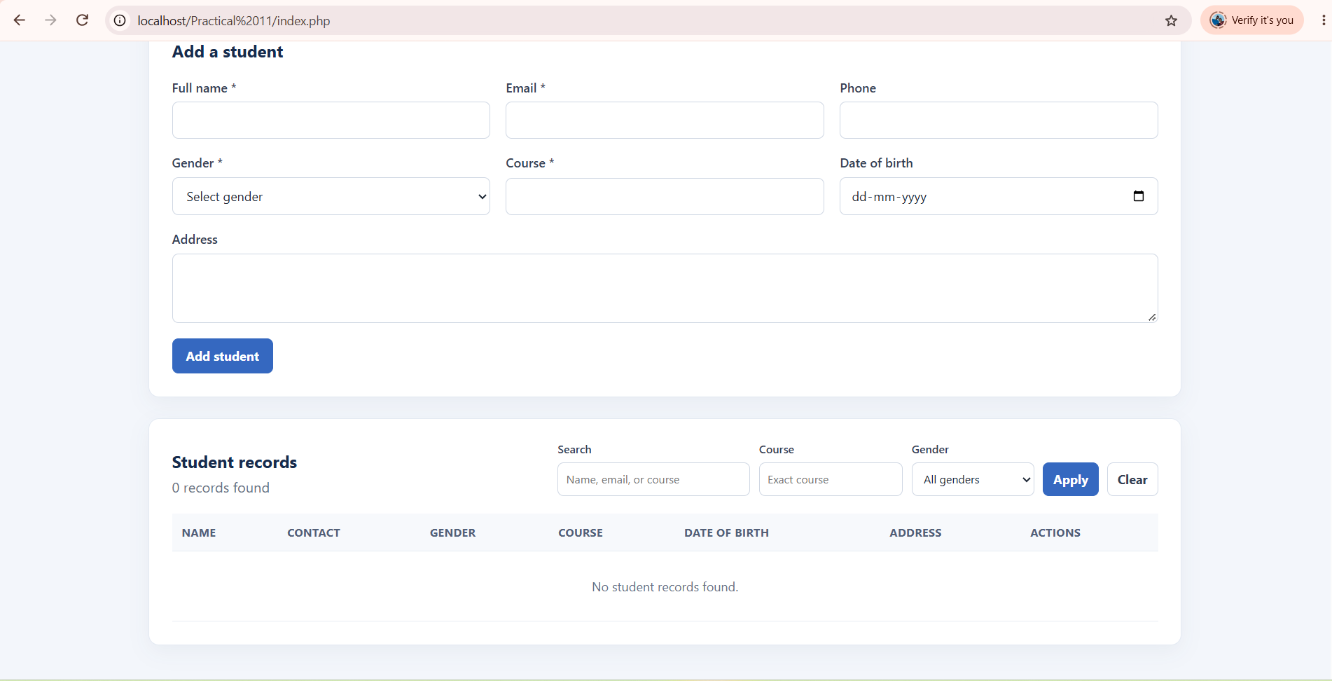

GitHub Repository Link:
Khushi-Thakor2007/Student-Hub-Portal

Challenges Faced:

Learning Outcomes:

Faculty Remarks:

